ELEC-2210

Digital Electronics

FROM: Jacob Howard

TO: Jonathan

DATE: 9/29/20

LAB SECTION: 002 (Tuesday, 1:00pm-2:50 pm)

EXPERIMENT 7:

BJT Transistors

# **Introduction**

# In this lab, we learned the function of BJT Transistors. This was our first Lab with BJT transistors, so we learned how they work and control output current. This lab had 5 steps, although, we did not have to do the last step.

# **Step 1**

In Step 1, we were asked to measure the forced IB output of the NPN transistor. Measing the transistor was quite simple. The graph is shown in *Figure 1*. Also the graph data is shown below in *Data 1.*

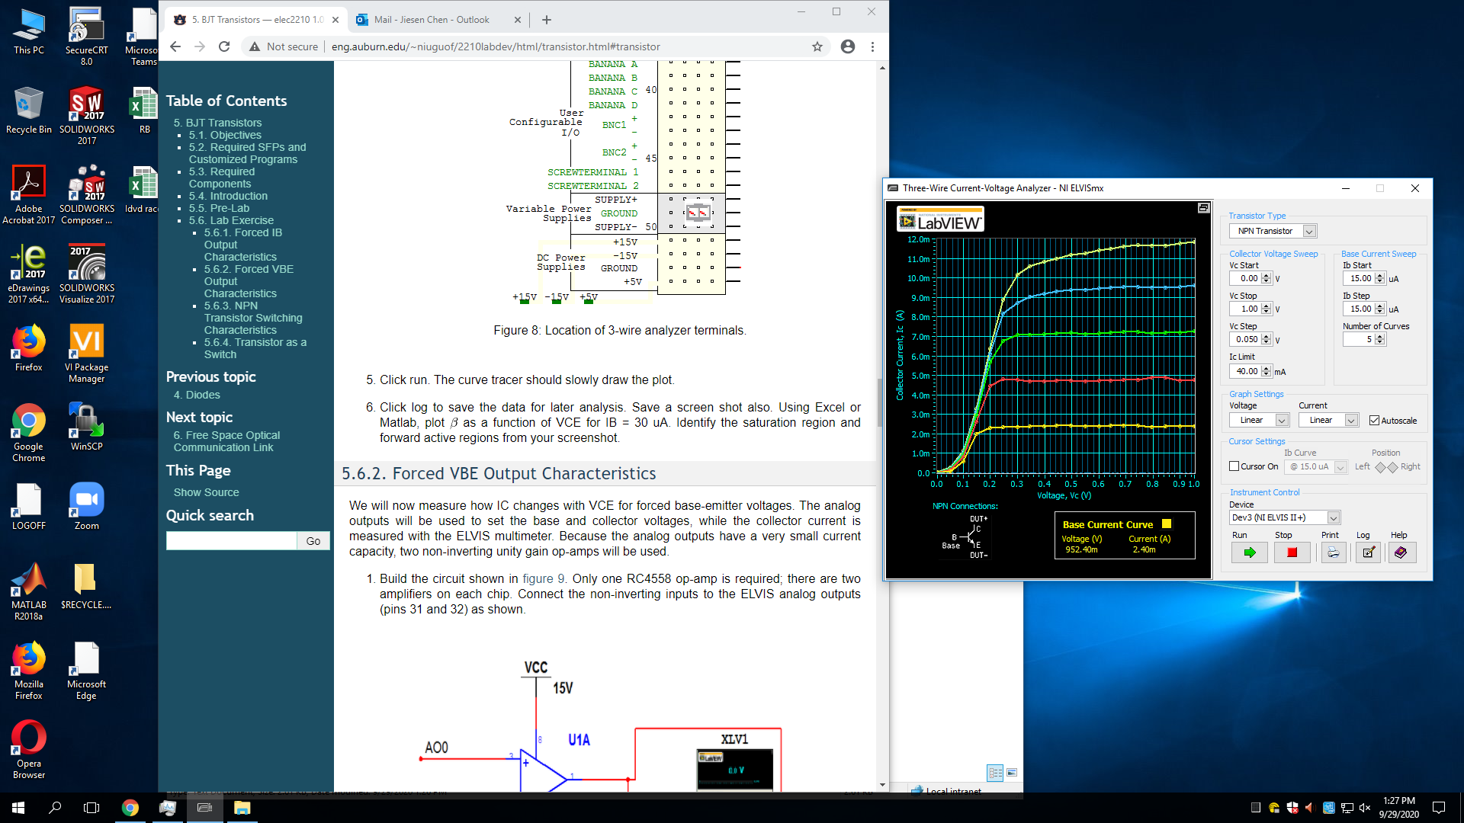

*Figure 1*

|  |
| --- |
| 9/29/2020 1:22 PM  Base current (µA): 15.0  Collector Voltage (V),Collector Current (A)  0.00432970 0.00000518  0.05252076 0.00007091  0.09948961 0.00033757  0.14763079 0.00083867  0.20031521 0.00148060  0.24692075 0.00203975  Base current (µA): 30.0  Collector Voltage (V),Collector Current (A)  0.00432970 0.00000835  0.05252076 0.00011862  0.09948961 0.00045369  0.14763079 0.00101358  0.20031521 0.00172977  0.24692075 0.00240364  Base current (µA): 45.0  Collector Voltage (V),Collector Current (A)  0.00432970 0.00001200  0.05252076 0.00015761  0.09948961 0.00053347  0.14763079 0.00112765  0.20031521 0.00184949  0.24692075 0.00256690  Base current (µA): 60.0  Collector Voltage (V),Collector Current (A)  0.00432970 0.00001551  0.05252076 0.00019240  0.09948961 0.00059455  0.14763079 0.00120119  0.20031521 0.00194470  0.24692075 0.00269291  Base current (µA): 75.0  Collector Voltage (V),Collector Current (A)  0.00432970 0.00002052  0.05252076 0.00021786  0.09948961 0.00064391  0.14763079 0.00125636  0.20031521 0.00200417  0.24692075 0.00282494 |

*Data 1*

**Step 2**

For part 2, we connected the circuit that was given to us in *Figure 2*. Our goal was to measure how IC changes with VCE for forced base-emitter voltages. We were provided a LabView program to download and use to get the graph and data. The graph is shown in *Figure 3* and the data for the graph is shown in *Table 1*.

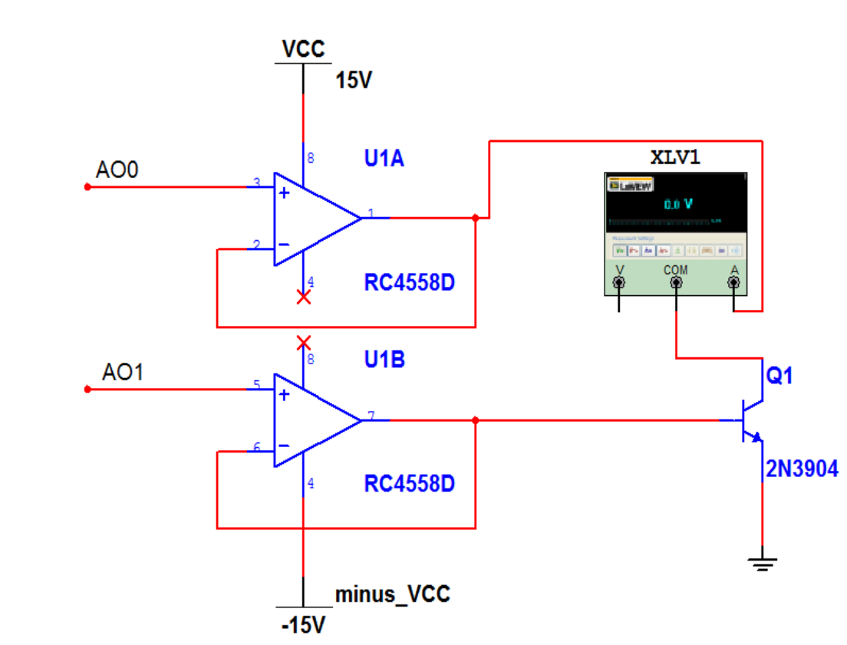

*Figure 1*

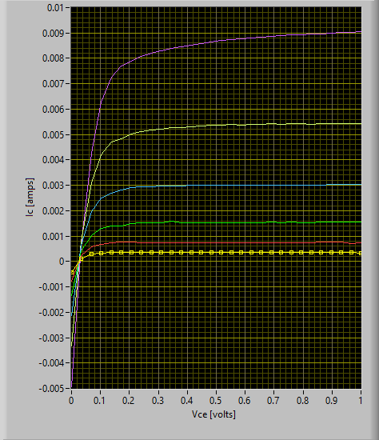

*Figure 2*



*Table 1*

*Table 2*

# **Step 3**

# In step 3, we were asked construct the circuit shown inn Figure 4. The circuit we constructed was essentially a BJT inverter, which could be used as an amplifier when bias point is set to the region where the output voltage changes fastest with the input voltage. We were provided another LabVIew program to provide 3 different graphs. The graphs are shown in *Figures 5 – 7*. The output starts to drop around Vin = 1V.

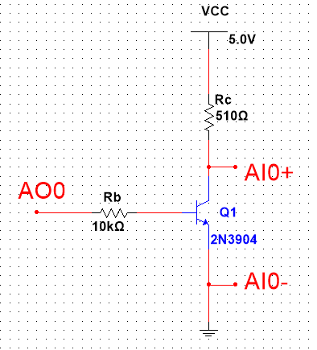

*Figure 4*

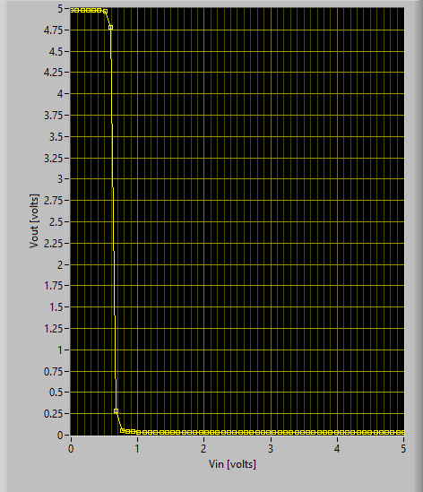

*Figure 5*

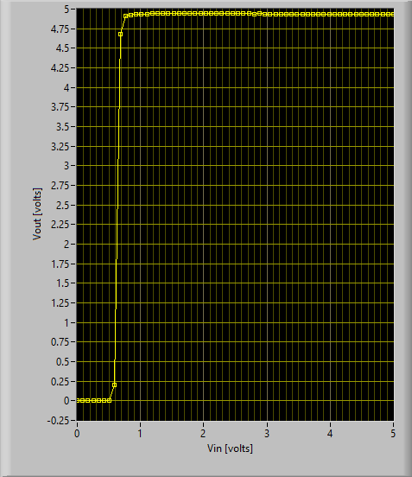

*Figure 6*

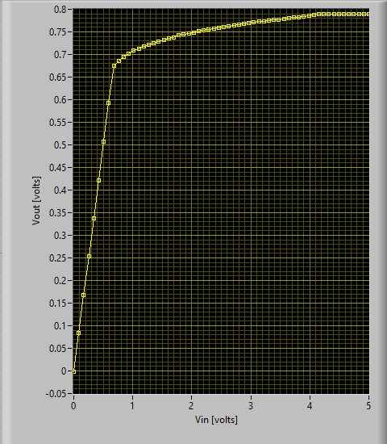

*Figure 7*

# **Step 4**

# In step 4, we were to demonstrate how the BJT really works. We were to consturc the circuit from Figure 8 onto the Breadboard. Having a low input voltage or current will turn the collector current off and a high input voltage or base current turns the transistor on. This basically means the transistor can be used as a switch depending on what input voltage or current you provide. After demonstraiting to the TA how the BJT can function as a switch to turn off and on the LED, we were to record measurements. The measurements are provided below in *Table 2.*

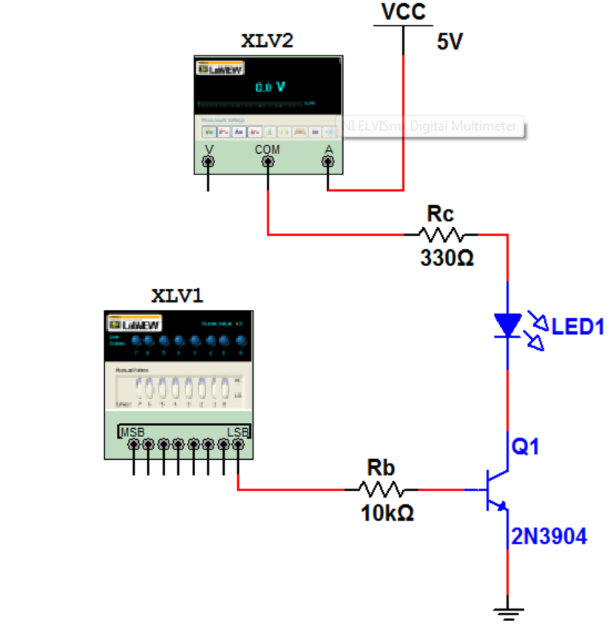

|  |  |  |
| --- | --- | --- |
| **LED** | **On** | **Off** |
| **VCE** | 5V | 0V |
| **VBE** | 0.75V | 0V |
| **VBC** | 0.64V | 3.47V |
| **IB** | 0.415mA | 0A |
| **IC** | 8.57mA | 0A |

# **Conclusion**

This was our first lab with BJT transistors. The lab was very interesting and helped us better understand how BJT Transistors worked. Overall, this lab was not too difficult and was very interesting , especially showing how we can use a transistor as a switch in a circuit.